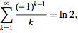

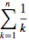 =
γ =
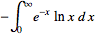

ψ₀(z) =
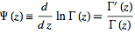

Γ(z) =
