A group task in discrete math:

Edited at 6am 13.3.2017.
Answer in your own words. Do not copy. Give the student numbers in the ascending order.

Introduction:

1. What is discrete math?
https://en.wikipedia.org/wiki/Discrete_mathematics

Sets:

2. Explain the set theory.
https://en.wikipedia.org/wiki/Set_theory
http://discrete4math.weebly.com/uploads/2/5/3/9/25393482/1sets.ppt

3. Give the expressions for cardinality of the union of the sets.

4. There are 2000 university students in total. 65 students take math. 80 students take physics. 1885 students take neither math nor physics. How many students take either math or physics? How many students take both math and physics? How many students take only math? How many students take only physics?

5. Find cardinalities and powers of each of these sets.
a. {6, 2, 1, 6, 0} b. {3, 2, 5, 8, 9, 11, 5, 3, 4}

6. Give the order of the sets operations and logical operations.

7. Give cardinalities and powers of each of these sets. a. {6, 2, 1, 6, 0} b. {3, 2, 5, 8, 9, 11, 5, 3, 4}

8. Find Cartesian product of these sets {p, g, a} and {7, 3, 1, 6}.

9. Prove.
a. A ∪ A ∩ B = A b. A ∩ (A ∪ B) = A c. (A ∪ B ∩ C)´ = (C´ ∪ B´) ∩ A´

10. Why is power set equal to 2 to the power of the cardinality?

11. Do men have on average more wives than women have husbands or the other way around? Why?

12. Move 1 stick to make the expression correct.
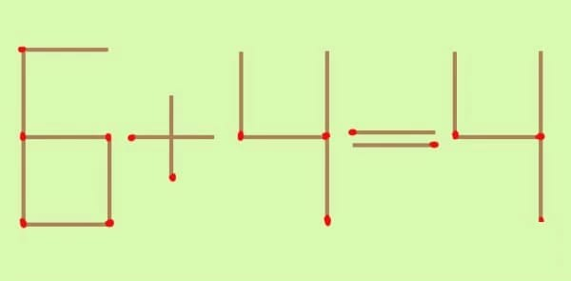
Give all the solutions.

Deadline: 18.3.2017.

