6 group task in discrete math:

Edited at 6am 6 August 2017.

1. Move 1 stick to make the expression correct.
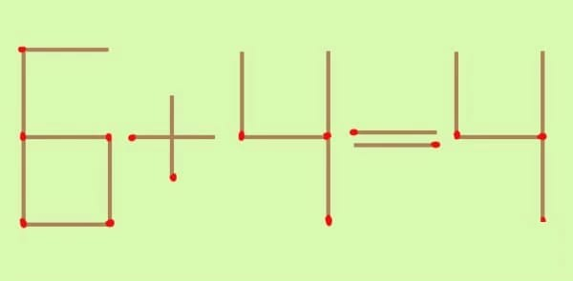
Give all the solutions.

Achievements:
2. What are the main achievements in discrete math in August of 2017?

Previous tasks:
3. Improve your answers to all group tasks and resubmit them.

Deadline: as soon as possible.

