1 group task in discrete math:

Edited at 3pm 21.9.2017.

Introduction:

1. What is discrete math?
https://en.wikipedia.org/wiki/Discrete_mathematics

Sets:

2. Explain the set theory.
https://en.wikipedia.org/wiki/Set_theory
http://discrete4math.weebly.com/uploads/2/5/3/9/25393482/1sets2017.ppt

3. Give the expressions for cardinality of the union of the sets.

4. There are 2000 university students in total. 65 students take math. 80 students take physics. 1885 students take neither math nor physics. How many students take either math or physics? How many students take both math and physics? How many students take only math? How many students take only physics?

5. Find cardinalities and powers of each of these sets.
a. {6, 2, 1, 6, 0} b. {3, 2, 5, 8, 9, 11, 5, 3, 4}

6. Give the order of the sets operations and logical operations.

7. Find Cartesian product of these sets {p, g, a} and {7, 3, 1, 6}.

8. Prove.
a. A ∪ A ∩ B = A b. A ∩ (A ∪ B) = A c. (A ∪ B ∩ C)´ = (C´ ∪ B´) ∩ A´

9. Why is power set equal to 2 to the power of the cardinality?

10. Do men have on average more wives than women have husbands or the other way around? Why?

11. Move 1 stick to make the expression correct.
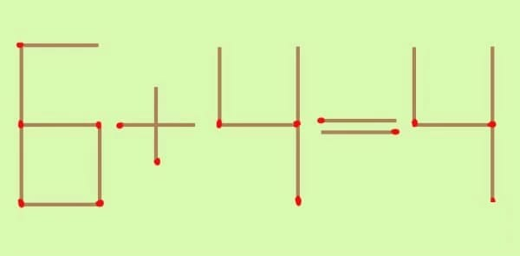
Give all the solutions.

12. Express the cardinality of the Cartesian product through the cardinalities of the original sets.

Logic:

13. Study the logic:
http://discrete4math.weebly.com/uploads/2/5/3/9/25393482/1sets2017.ppt
http://discrete4math.weebly.com/uploads/2/5/3/9/25393482/2propositions.ppt
http://discrete4math.weebly.com/uploads/2/5/3/9/25393482/3proofs.ppt

14. Define a proposition, atomic proposition and compound proposition.

15. Explain Boolean Arithmetic. http://www.allaboutcircuits.com/textbook/digital/chpt-7/boolean-arithmetic/

16. Give arithmetic equivalents of sets and propositional operations.
17. Give the truth tables for the main logical operations.

18. Find the truth tables.
a. A or not B and C
b. C and not B or not (A or D)

19. Explain modus ponens and modus tollens.

20. Give converse, inverse and contrapositive to “If I study hard, then I will be rich.”

21. Give and explain De Morgan’s laws. Why are they used?

22. What is the implication?

Proofs:

23. Explain the main methods of mathematical proof.

24. Explain proposition, tautology, contradiction, contingency, syllogisms, and predicates.

25. Prove that $\sqrt{2}$ is irrational number.

26. Prove the expressions for the sums of the terms of arithmetic and geometric progressions.

27. Give the main methods of poof.

http://discrete4math.weebly.com/uploads/2/5/3/9/25393482/3proofs.ppt

28. Prove the Triangular Number expression $\sum_{c=0}^{j}{c= \frac{j(j+1)}{2}}$, j is any natural number.

29. Prove that $\sqrt{2}$ is irrational number.

30. Prove the expressions for the sums of the terms of arithmetic and geometric progressions.

31. Prove by contradiction:
“IF 3n + 2 is odd, then n is odd”

32. Prove by contraposition:
“IF 3n + 2 is odd, then n is odd”

Deadline: 30.9.2017.

